Chapter 3, Solution 44

Use mesh analysis to obtain i_{o} in the circuit of Fig. 3.90.
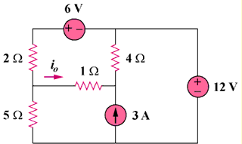

90 V

180 V

45 A

Figure 3.90
For Prob. 3.44.

Solution
–
+

180V
+ –

90 V

45 A

i₁

i₂

i₃

4 Ω

5 Ω

2 Ω

1 Ω

i₁

i₂

Loop 1 and 2 form a supermesh. For the supermesh,

6i₁ + 4i₂ – 5i₃ + 180 = 0 (1)

For loop 3, –i₁ – 4i₂ + 7i₃ + 90 = 0 (2)

Also, i₂ = 45 + i₁ (3)

Solving (1) to (3), i₁ = –46, i₃ = –20; i_{o} = i₁ – i₃ = –26 A

